Relating with others in an acceptable way.

**Learning outcome:**

Identifying taking interest and observing people around me. E.g father, mother, sister, brother, baby

**Materials:** Visual aids

* Cards

**Activity:**

Shade the people at home.

Father mother

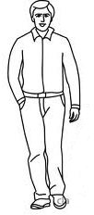 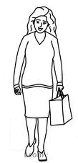

**LESSON 2**

Shade people found at home.

Sister brother baby

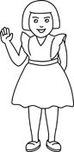 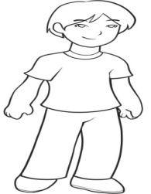 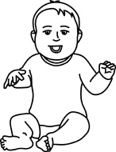

**LESSON 3**

Match the same people at home.

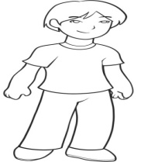 

 

 

**LESSON 4**

Copy and draw people found at home.

|  |  |  |  |
| --- | --- | --- | --- |
|  | Image result for sister images black and white | how-to-draw-a-boy-for-kids-step-9_1_000000048713_5 |  |
|  |  |  |  |

**Competence:**

Shows acceptable behaviour to people he / she plays with.

**Materials**: Visual aids

**Behaviours**

* Greeting the teacher / themselves
* Saying sorry to a friend
* Thanking
* Requesting
* Responding to commands
* Obeying instructions
* Apologizing

**LESSON 1 AND 2**

Tracing pupils greeting each other

**LESSON 3 AND 4**

**Materials**: Visual

* Picture cards.

**Procedure:**

The lesson with be introduced with a song

Good morning x 3

This is a loving day

Good morning x 3

We love to dance and play

**Learner’s activity:**

Shade a boy saying sorry to a friend

**L.O.3**

Sharing with and taking care of other people.

**Competence:**

Participates in group activities

**Materials: -**

Real things like bottles, balls, cakes, sodas.

**Procedure:**

The lesson will be introduced with a song

Clap x 2 I like it

Wave x 2 I like it

Jump x 2 I like it

**LESSON 1 AND 3**

Making gifts

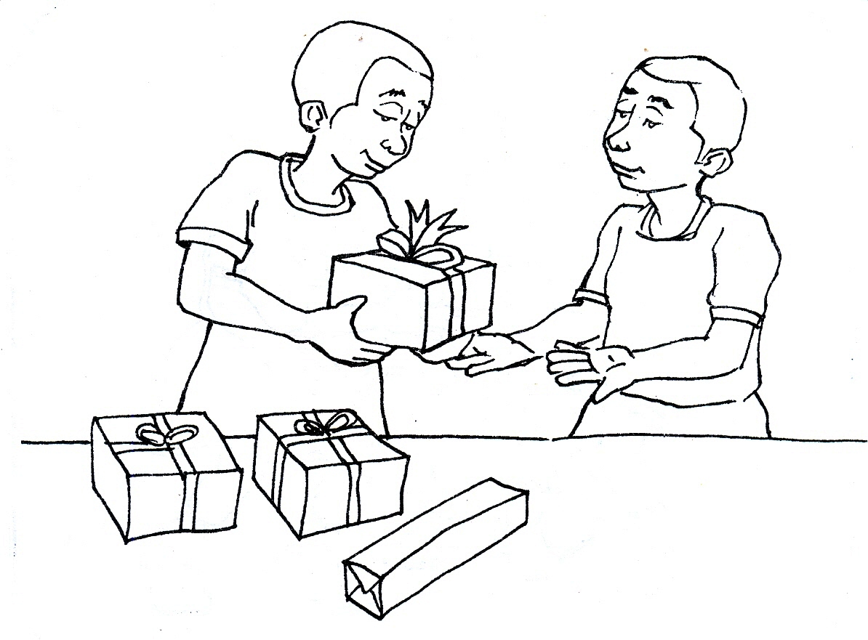

**LESSON 4**

**Procedure:**

The teacher introduces the lesson with a song.

“Let’s jump together x 2

Jump x , we jump 2

This way, we jump x 2

that way we jump x2

all the way and turn around

* Let the teacher demonstrate how to share gifts.
* The learners will indentify and share the gift.

**Learner’s activity:**

Shade the gift.

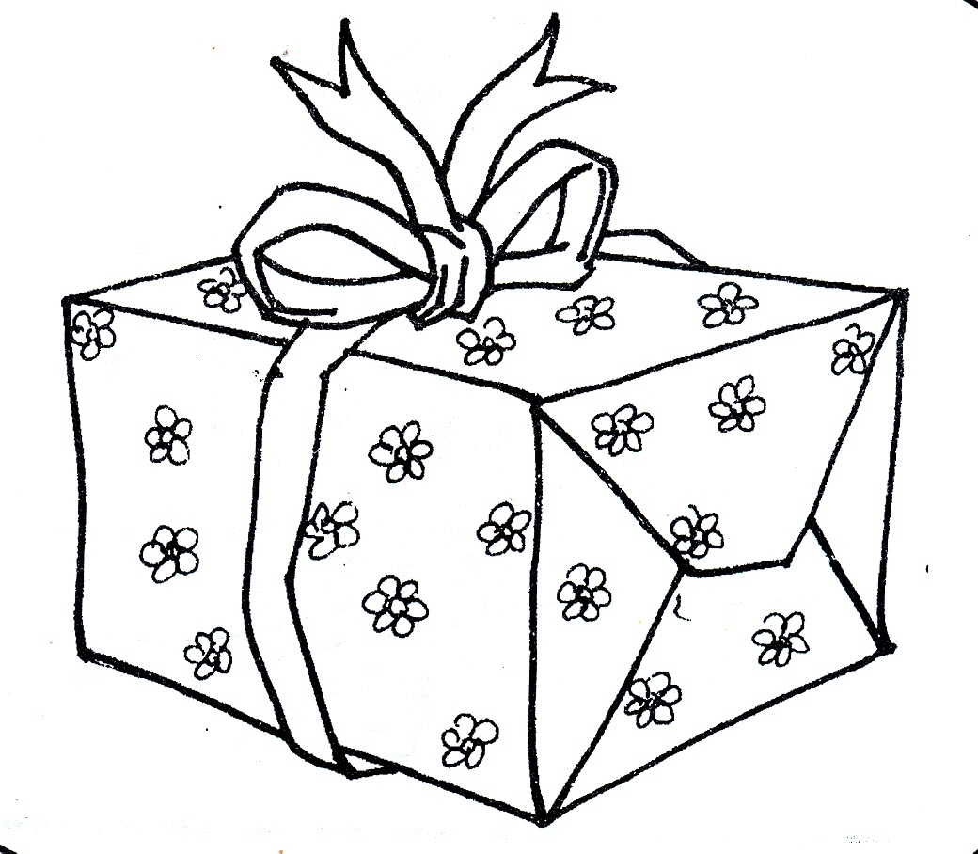

MORE PRACTICE WORK TERM I

**LEARNING AREA I (SOCIAL DEVELOPMENT)**

**PEOPLE AT HOME**

**Name people at home orally**

**Content**

Shade a sister

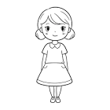

Shade your father

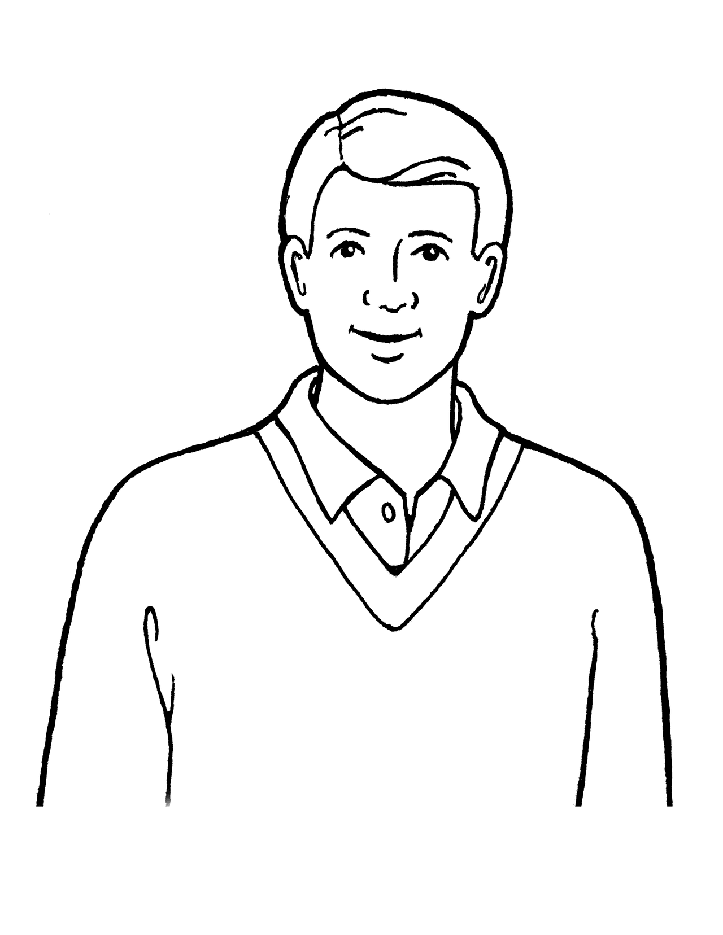

Shade your mother

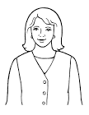

Shade your brother

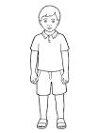

Shade a baby

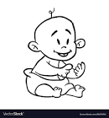

**Matching**

**Match the same**

Shade a sister

 

 

 

Match

 

 

 

**THINGS IN THE CLASS**

**Match**

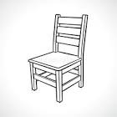

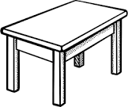 



**Match the same**

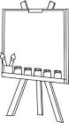

 



**Match**

 

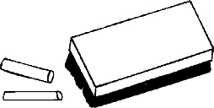 

 

**THINGS WE USE AT HOME**

Shade a chair



Shade a cup



Shade a bed

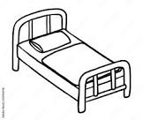

Shade a mat



Shade a pot.

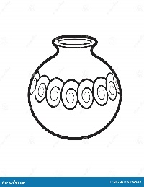

Shade a jerrycan

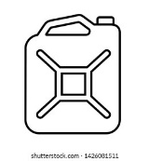

Shade a table



Shade a television



Shade a radio



Circle the same

 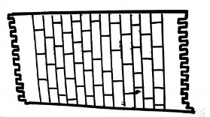 

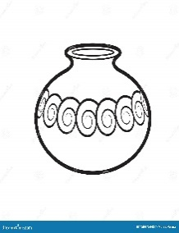  

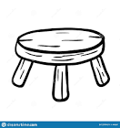  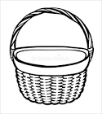

Match the same

 

 

 

**Oral work**

1. What is your name?
2. In which class are you?
3. Are you a boy or a girl?
4. Who is your friend?
5. Who are your teachers?
6. Where do you go to school?
7. What is the colour of the sun?
8. On which day do you go to church?
9. Where do you live?
10. Tell me things in the class.